Position Control

HexaMotor
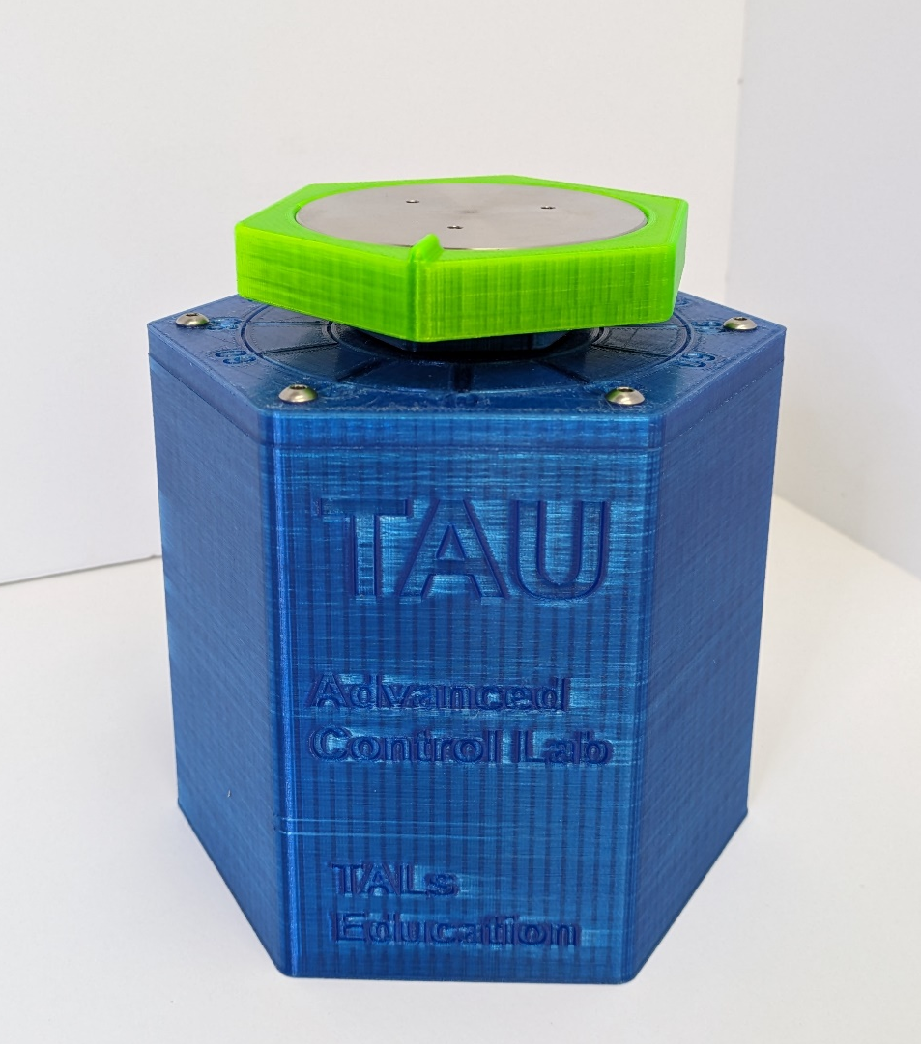
Experiment objectives:
• Introduction to second order systems.
• Coulomb Friction identification and handling.
• System identification using position close loop step reponse.
• System identification using position close loop frequency reponse.
• Position control implementation based on second order system modeling.
• Lead-Lag compensator controller design and implementation.

Introduction
In the field of motor control, mastering both velocity and position control is essential for a wide range of applications. While the previous lab experiment delved into the nuances of velocity control and the fundamentals of a DC motor, this experiment pivots to emphasize position control. Position control, vital for accurate maneuvering and precise positioning of mechanisms, demands its own unique approach. This experiment outlines objectives ranging from system identification using step and frequency responses to the design and actual implementation of control strategies.

First order approximation
While in the previous experiment the full equations of the DC motor were presented and the first-order approximation was derived, in this experiment we will contrinue working with the first-order approximation of the DC motor.
First-Order Transfer Function:
  - $G\left(s\right)=\frac{K_{T}}{\left(RJ\right)s+(BR+K_{T}K_{b})}$ ; $G\left(s\right)=\frac{K_{m}}{τs+1}$

Coulomb friction
Recall from the previous experiment that Coulomb friction, which remains constant irrespective of motor speed, contributes to system non-linearity and can pose challenges in control implementation, particularly at low speeds. We identified this friction by applying a controlled voltage to the DC motor, observing the threshold voltage initiating rotation.

Second order systems
When discussing control systems, a second order system is frequently encountered. It can be described by the standard second-order transfer function:
  - $T\left(s\right)=\frac{K}{s^{2}+2ζω_{n}s+ω_{n}^{2}}$
Where:
K – is the system static gain.
$ω_{n}$ – is the undamped natural frequency.
ζ – is the damping ratio.
The system's response is primarily characterized by its damping ratio ζ and natural frequency $ω_{n}$
Several performance metrics can be derived from the above standard form:
Percent Overshoot (%OS):
It defines the amount by which the transient response exceeds the steady-state value. For a step response, the percent overshoot is given by:$OS=100e^{\frac{-πζ}{\sqrt{1-{ ζ}^{2}}}}$ It should be noted that overshoot occurs only when $ζ$<1 (underdamped case).
Rise Time (Tr):
The time it takes for the response to rise from 10% to 90% of its final value for an underdamped system. While there's no direct closed-form formula, for many systems with a damping ratio between 0.4 and 0.7, the rise time is approximately: $T_{r}≈ \frac{1.8}{ω_{n}}$
Settling Time (Ts):
The time for the system response to stay within a certain percentage (usually 2% or 5%) of its final value. It's given by $T_{s}≈ \frac{4}{{ ζω}_{n}}$ for a 2% settling time.
Peak Time (Tp):
The time it takes for the response to reach its first peak. For an underdamped system: $T_{p}= \frac{π}{{ ω}_{d}}$ where ${ ω}_{d}= { ω}_{n}\sqrt{1-ζ^{2}}$ is the damped frequency.
Natural Frequency (${ ω}_{n}$​):
It's the frequency at which the system would oscillate if there were no damping (i.e., ζ=0).

Root Locus
The essence of the root locus lies in its depiction of system dynamics. The locations of the closed-loop poles directly influence the transient response characteristics of the system. By examining the root locus, engineers can predict how changes to the system gain will impact crucial performance metrics such as overshoot, settling time, and oscillation frequency.
The foundation of the root locus method is built on two fundamental principles:
- Magnitude Criterion: At any point on the root locus, the product of the magnitudes of the vectors from all open-loop zeros to that point divided by the product of the magnitudes of vectors from all open-loop poles to that point is equal to 1 (or the gain at that point).
- Angle Criterion: For a point to lie on the root locus, the sum of angles from all open-loop zeros and poles to that point must equal an odd multiple of 180°.
Armed with these criteria, control system engineers can sketch the root locus and use it to select appropriate gains that yield desired closed-loop behavior. Not only does the root locus offer insights into system stability (since poles in the right half of the complex plane denote instability), but it also aids in shaping the system response to meet specified design criteria.

PID controller
As previously discussed in our prior experimentation, the PID controller is a predominant feedback control algorithm extensively employed in industrial applications due to its efficiacy across diverse scenarios and its systematic tuning methodology.
  - $u\left(t\right)=K_{p}e\left(t\right)+K_{i}\int{e\left(t\right)dt}+K_{d}\frac{de(t)}{dt}$
The PID controller is characterized by three fundamental components:
Proportional (P): This component yields a control action that is directly proportional to the instantaneous error. The magnitude of this response is governed by the proportional gain
Integral (I): Concerned with the aggregation of error over time, this action aims to nullify any persistent steady-state error.
Derivative (D): This term offers a control action based on the rate of error change, effectively anticipating potential future errors and generating a preemptive control response. In practical applications, a distant pole is introduced to filter out system noise. In our case, the derivative element is filtered by a first-order pole set at half the sampling frequency.

Lead-Lag Compensator
Lead and lag compensators are essential tools in control theory, particularly in the design of feedback control systems to meet transient and steady-state response specifications:
Lag Compensator: The general transfer function for a lag compensator can be described as:
  - $G_{Lag}= \frac{1+τs}{1+aτs}$
Where τ is the time constant and a>1.
Purpose: The primary purpose of a lag compensator is to improve the steady-state response of the system. This is done by adding a pole and a zero to the system. Since the zero is closer to the origin than the pole, the compensator will have a magnitude less than one for most frequencies, thereby reducing the gain of the system and the steady-state error.
Placement: The zero is placed to the left of the pole. The distance between them determines the magnitude of the phase boost, but a lag compensator will not introduce a significant phase lead.
Drawbacks: Lag compensators generally degrade the transient response because they tend to reduce the system bandwidth.
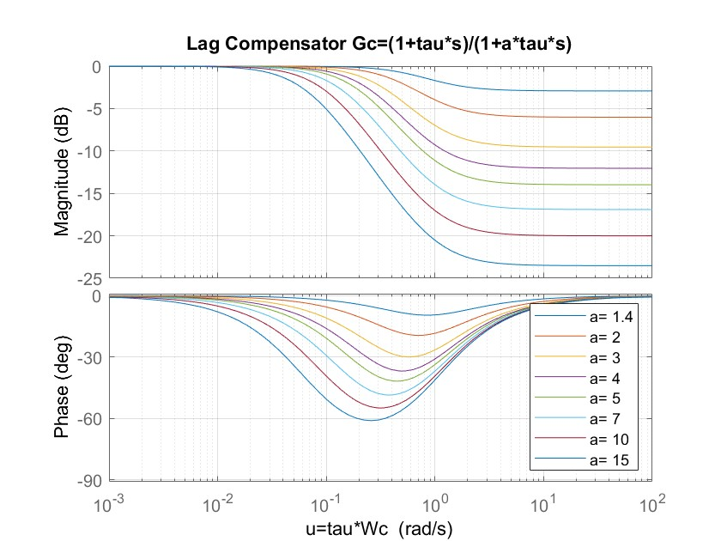
Figure 1 Lag Compensator plot using LeadLad.m scrip

Lead Compensator: The general transfer function for a lead compensator can be described as:
  - $G_{Lead}= \frac{1+aτs}{1+τs}$
Where τ is the time constant and a>1
Purpose: The primary purpose of a lead compensator is to improve the transient response of the system. By placing a pole and a zero in the left half plane, it introduces phase lead to the system, which can be used to reshape the root locus or push the closed-loop poles to desired locations.
Placement: The zero is placed to the right of the pole, introducing phase lead in the frequency range of interest. The amount of phase lead is determined by the distance between the pole and zero and their proximity to the imaginary axis.
Drawbacks: Because of the introduced phase lead, a lead compensator also increases the gain in some frequency range. This can make the steady-state error worse.
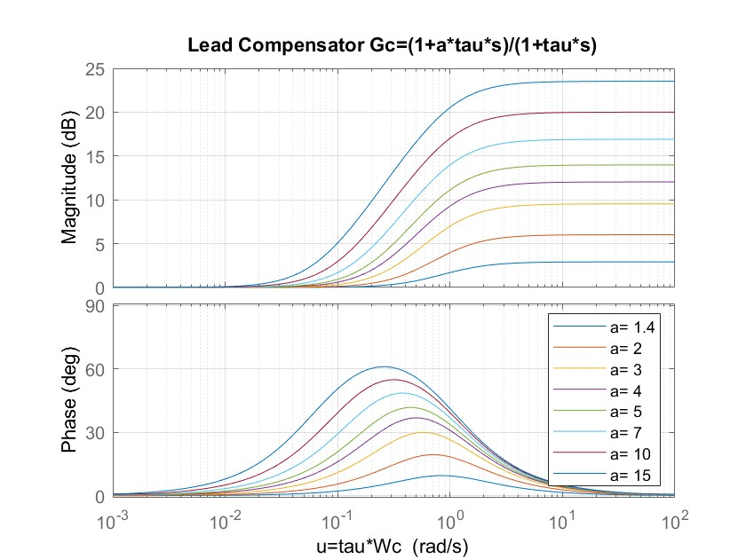
Figure 2 Lead Compensator plot using LeadLad.m scrip
Design Considerations:
Lag: When using a lag compensator, the goal is often to place the pole and zero sufficiently far from the imaginary axis, so they don't affect the transient response. You place the zero so that the magnitude of the system is unchanged at the crossover frequency.
Lead: When designing with a lead compensator, the goal is often to add enough phase lead to achieve desired transient characteristics without pushing the gain crossover frequency too high.
In practice, combining both lead and lag compensators can offer an optimal balance between steady-state and transient performance in many systems.
Graphical approach for Lead Lag design:
Run the "LeadLag.m"
- The script "LeadLag.m" generates plots associated with the lead-lag compensator design. This includes various curves representing different amounts of phase lead and the corresponding gains for different values of a (since a lead compensator's behavior is determined by its zero and pole locations, which are in turn determined by the parameter a and the time constant τ).
Open-Loop Bode Plot:
- Start by plotting the open-loop Bode plot of the system. From this plot, you'll identify the current crossover frequency $ω_{c}$and the existing phase margin.
Determine Required Phase Boost:
- Based on system specifications or desired closed-loop performance, determine how much additional phase you want to introduce.
Iterative Process for Design:
- Use the provided lead graph (generated by the script) to identify a point that provides the necessary phase boost.
- From the corresponding gain graph, note the gain added due to the lead compensator.
- This added gain will shift $ω_{c}$ in the open-loop Bode plot.
- Now, with this new $ω_{c}$ the phase requirements might be slightly different. So, you may need to iterate this process to ensure that the final selected values of phase and gain boosts provide the desired performance.
Calculate the Lead Compensator:
- Using the relationship and the equation provided: $G_{Lead}\left(s\right)=\frac{1+aτs}{1+τs}$​
- And given: $τ= \frac{u}{ω_{c}}$ Where:
- τ is the time constant of the lead compensator.
- a is the gain boost and defines the curve.
- u is the specific point on the curve/graph which dictates the amount of phase lead and gain boost introduced.
- $ω_{c}$​ is the new crossover frequency after introducing the compensator.
Implement and Test:
- Once the lead compensator parameters are determined, you can then apply them to the system and validate if the system's response matches your design specifications. You may also need to iterate the design process if the initial compensator doesn't provide the desired results.
This process essentially allows you to design a lead compensator using graphical methods, taking advantage of the insight provided by Bode plots and the relationships between phase lead, gain boost, and compensator parameters.

Pre Lab

Second order system identification
Identifying the First Order Transfer Function of a DC Motor Using Closed-Loop Step Response in Position Feedback
In this method, the behavior of the DC motor under position feedback is contrasted with a canonical second-order system, described by $T\left(s\right)=\frac{K}{s^{2}+2ζω_{n}s+ω_{n}^{2}}$. The benefits of this comparison are twofold. Firstly, second-order systems are thoroughly understood and have been extensively studied, offering a benchmark against which the motor's dynamics can be evaluated. Secondly, essential performance metrics — including overshoot, peak time, rise time, and settling time — can be directly correlated to the system's damping ratio, ζ, and its natural frequency, $ω_{n}$.
Armed with these metrics from experimental observations and a known feedback gain, it's possible to determine the inherent characteristics of the DC motor, especially its time constant, τ, and gain, $k_{m}.$
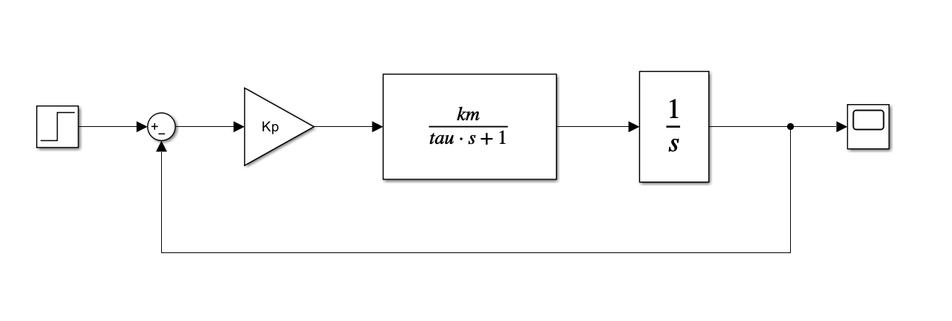
Figure 3 Simulink model representing close loop system
- Given the system above, assuming the plant is a DC motor using its first order approximation $G\left(s\right)=\frac{k_{m}}{τs+1}$, write what the blocks represent and the units of the input and output signals.
- Given the system above, what is the close loop transfer function:
- Compare the transfer function derived in b. To the standard second order transfer function of the form $T\left(s\right)=\frac{K}{s^{2}+2ζω_{n}s+ω_{n}^{2}}$. Find representations of $ζ$ and $ω_{n}$ as a function of $τ$ , $k_{m}$ and Kp
- Using Matlab, plot the step response of the following first order system $G\left(s\right)=\frac{2.5}{0.1s+1}$, using the system represented above with gain of Kp=10.
- Based on the peak time and over-shoot performance metrices for a standard second order system. Find the values of $ζ$ and $ω_{n}$.
- Based on the equations derived in C verify the transfer function of the DC motor in the form of $G\left(s\right)=\frac{k_{m}}{τs+1}$
- Using root locus plot for the DC motor transfer function G verify that the over-shoot, $ζ$ and $ω_{n}$ for Kp=10 is the same as measured and calculated in d,e (up to a small rounding error). explain how root locus can be beneficial in designing a proportional controller.

PD controller
Tuning a PD Controller for a DC Motor Using Canonical Second-Order Transfer Function Analysis
In this approach, the behavior of the DC motor, when coupled with a PD controller, is compared with a canonical second-order system described by $T\left(s\right)=\frac{K}{s^{2}+2ζω_{n}s+ω_{n}^{2}}$​. Such a comparison offers two primary advantages. Firstly, the canonical second-order systems serve as a well-defined benchmark, given their extensive study and well-understood dynamics. Secondly, by mapping desired system response characteristics, such as overshoot (OS) and peak time, to the parameters of this second-order system, one can directly relate them to the controller gains, Kp​ and Kd​.
Through this method, it becomes possible not only to tune the PD controller for a specific DC motor but also to have a systematic approach to achieving desired dynamic characteristics. By tailoring Kp​ and Kd​ based on the insights from the second-order comparison, one can design a controller that meets specific performance metrics, paving the way for optimal system operation.
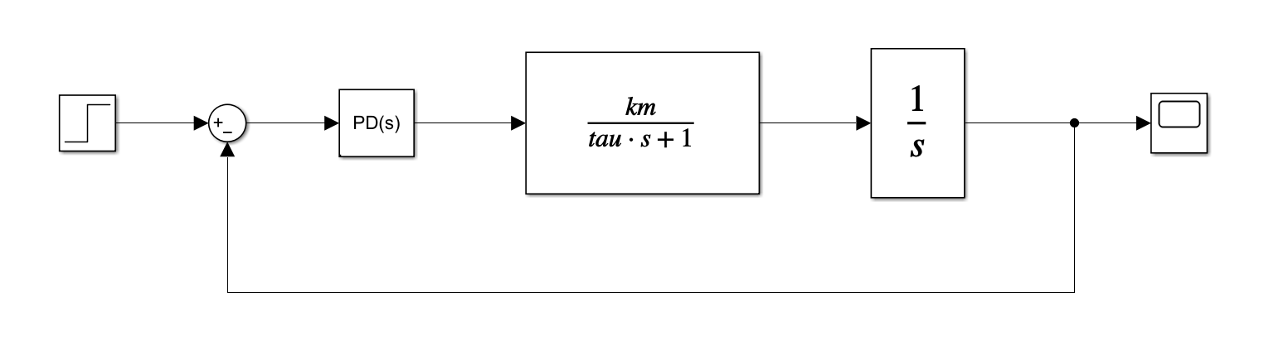
Figure 4 Simulink model representing close loop system
- Given the system above, assuming the plant is a DC motor using its first order approximation $G\left(s\right)=\frac{k_{m}}{τs+1}$, and $PD\left(s\right) \left( is a proportional derevative controller\right)$ of the form:
$PD\left(s\right)=k_{p}+k_{d}s$. What would be the close loop transfer function $T_{1}\left(s\right)$.
- Compare the poles of the transfer function $T_{1}\left(s\right)$ to the poles of the standard second order system represented as $T_{2}\left(s\right)=\frac{K}{s^{2}+2ζω_{n}s+ω_{n}^{2}}$. And find representation of $ζ$ and $ω_{n}$ as a function of $k_{m}, τ, k_{p} and k_{d}$.
- Find the values of $ζ$ and $ω_{n}$ which will result in a step response for the standard second order system $T_{2}\left(s\right)=\frac{K}{s^{2}+2ζω_{n}s+ω_{n}^{2}}$ with the following criteria: %OS of 25% and $T_{p}=0.20 [seconds]$.
- Based on the equations found in b. And assuming the motor has a transfer function of
$G\left(s\right)=\frac{2.5}{0.1s+1}$ find the values for $k_{p} and k_{d}$.
- Simulate the system at a. (in matlab or simulink). using the found controller gains and dc motor transfer function from d. What can you say about its %OS, $T_{p}$ ? why is it slightly different from the designed OS%, $T_{p}$. Plot the step response of the system and mark OS%, $T_{p}$.

Lead-Lag compensator
Graphical Approach to Lead-Lag Compensator Design for DC Motor Performance Enhancement Using Bode Plots
By graphically analyzing the Bode plots, one can visually discern the system's frequency response shortcomings. The "lead" in the compensator can be tailored to boost phase margin and speed up system response, while the "lag" part can be optimized to improve steady-state accuracy. Through a methodical graphical approach, not only is it possible to pinpoint where compensation is needed but also to sketch the compensator's frequency response right on the Bode plot, ensuring an intuitive and interactive design process.

Figure 5 Simulink model representing close loop system
- Given the system above, and using the values from the previous section, plot in matlab the open loop bode of the system ($PD\left(s\right)∙P(s)$ whereas $P\left(s\right)=\frac{k_{m}}{s(τs+1)}$ )and evaluate the $ω_{c}$ (crossover frequency) and phase margin of the system.
- Design a lead lag compensator to fix the Phase margin to $60°$ . Add to the bode plot in a. the compesated bode and mark the new $ω_{c}$ , Phase margin. Plot the step responses from both of the systems on the same graph. Mark the OS%, $T_{p}$. Of both. (use the graphical method or any other method of your choice).

In Lab

Introduction
Welcome back to the lab! Before diving into our experiments, please take a moment to reacquaint yourself with our hardware. You'll be using the HexaMotor setup, which features a DC motor paired with an encoder and linked to an Arduino Uno R4 Minima board and a motor driver. You can operate it through MATLAB Simulink. For more details, refer to the appendix of this manual.
- Start by opening MATLAB R2026b (with the Arduino support packages and the R4 Minima patch installed, see the Appendix)
- Navigate to …\Documents\MATLAB
- Create a new folder with your name and copy the lab materials into it
- Open “HexaMotor_MotorTest_V03.slx” Simulink model.
- Prior to running the model make sure the setup is connected to the PC through USB cable and the power supply is connected to the socket.
- Make sure the rotating mass is present. (same configuration as in the velocity control experiment)
- Under hardware you will find the Monitor&Tune button, press it, if everything is properly set it will compile the Simulink model and upload a C++ code to the micro controller. When the process has finished the button with be switch to a stop button and at the button bar a simulation time will start counting.
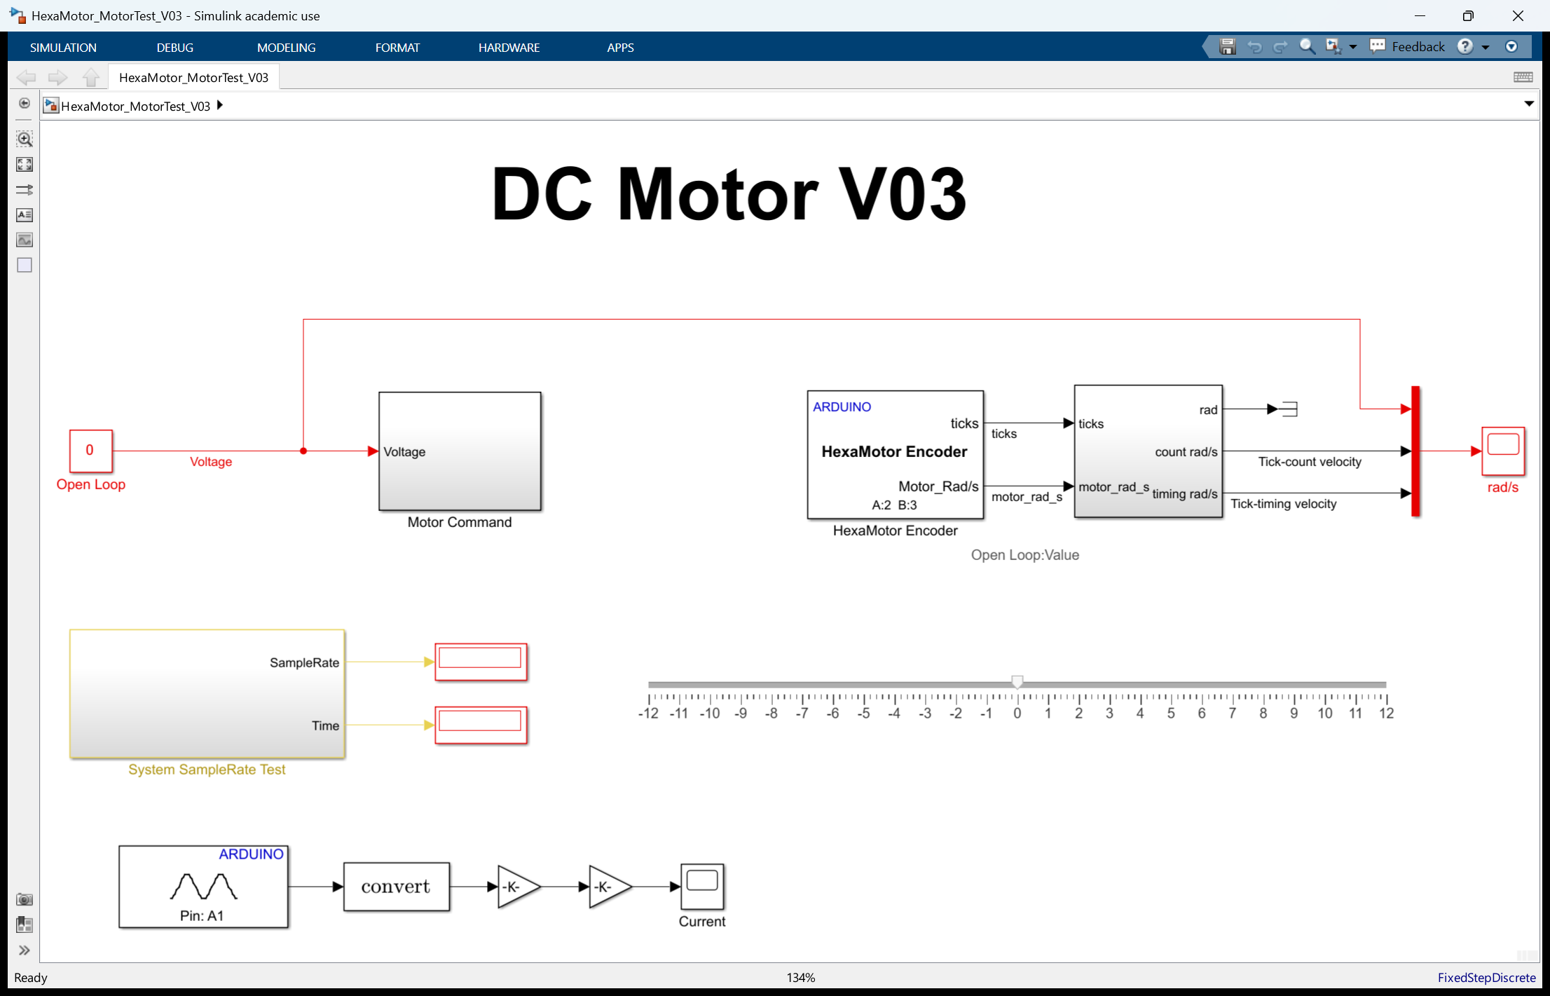
Figure 6 Simulink model for interaction with the HexaMotor Setup

Revisiting Coulomb Friction
Let's delve deeper into the system by reexamining the Coulomb friction present. Often termed 'dry friction', Coulomb friction consistently opposes motion and remains unaffected by the varying velocity between surfaces. Within a brushed DC motor's framework, this is perceived as the Dead-Zone. This Dead-Zone denotes the area where, despite voltage being administered, the motor remains static. This immobility arises primarily when the exerted voltage or torque falls short of conquering the system's innate static friction. Pinpointing and rectifying this Dead-Zone is pivotal for the motor's seamless operation, especially during its initial phases and at slower speeds.
- Using the same “HexaMotor_MotorTest_V03.slx” Simulink model. Find the minimum voltage values required to start the motor motion. You can change the slider range if you wish to use it to find the minimal values.
You can push the motor a bit with your hand and try to find the least resistance angle. (due to the non-linearity in the friction mentioned earlier).
- Write those values for next section.

Step response modeling
Let's now transition to our next experiment: exploring the first order transfer function of a DC motor using the closed-loop step response in position feedback.
- Open the “HexaMotor_Position_Control_V03.slx” Simulink model. Make sure the switch is set to Pulse Generator input.
- Set the Motor Friction Preamp constants: a positive value in the upper constant and the same negative value in the lower constant. Use at most 0.5 V, even if the start voltage you measured in the previous section is higher: the pre-amp is also applied when the command is zero and it switches sign with the command, so a higher value can make the motor jump or oscillate around its target. Talk to the TA before setting a value higher than 0.5 V.
- Adjust the PD controller to proportional only with kp=10, Ki=0 and Kd=0 (the PID block of the V03 models has Ki=5 by default), keep the Pulse Generator amplitude at 1 rad and update the stop time to 30 seconds.
- Run the experiment
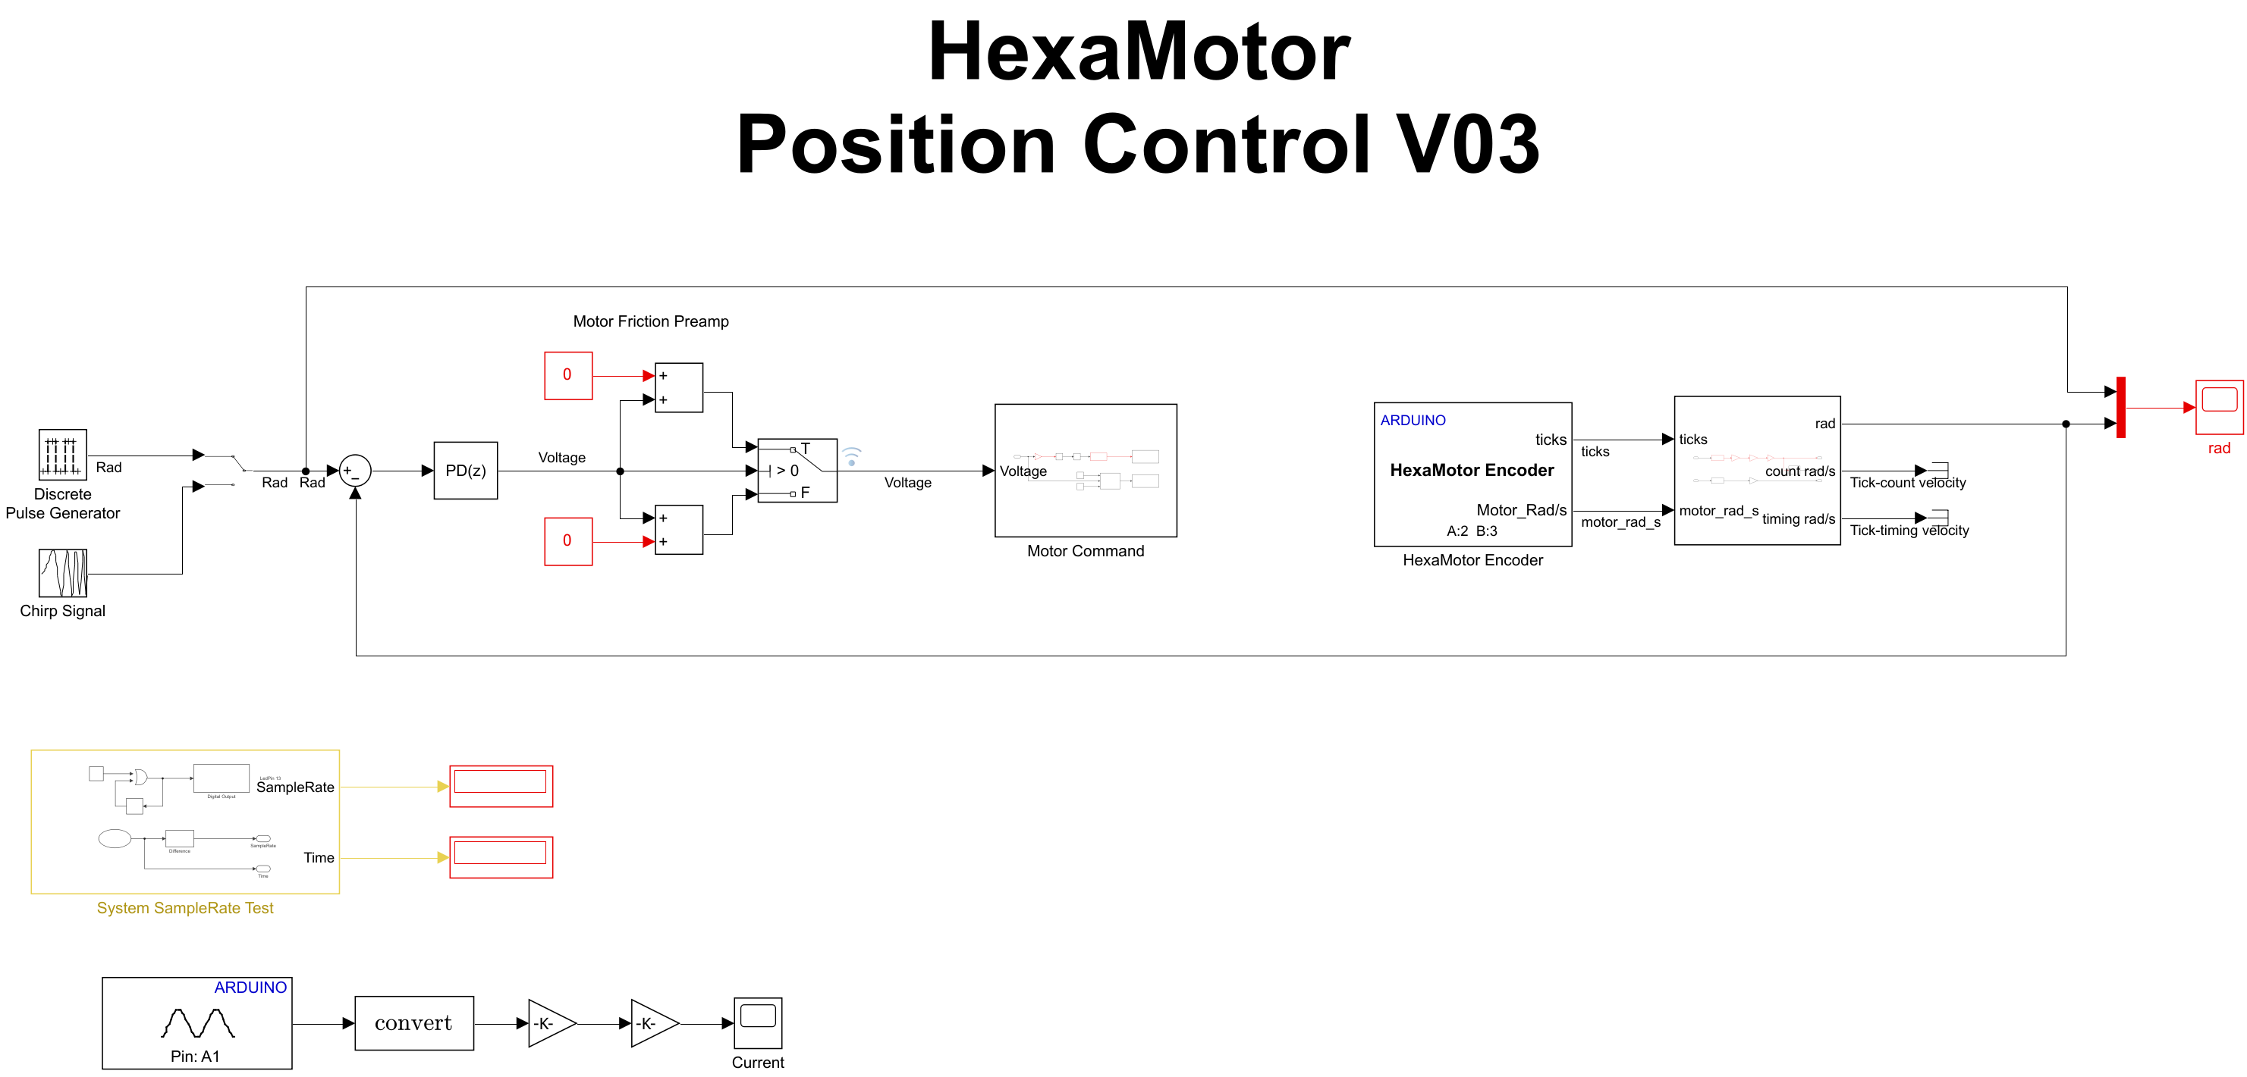
Figure 7 Simulink model : "HexaMotor_Position_Control_V03.slx”
For the Report:
- Using the closed-loop step response, estimate the DC motor's transfer function following the method previously described and practiced in the pre-lab section.
- Create a plot in Matlab which contains the response from the recordings and as a simulation using the lsim function in Matlab for the identified transfer function. Mark peak time and over-shoot values for both signals.
Hint: use the following Matlab commands: (do not forget to update the transfer function and add grid, axis labels, title to the plot).
% Generate plots from recordings and simulated transfer function
s=tf('s');
Kp = 10;
G = 2.5/(0.1*s+1)/s; % update the transfer function values
figure(1)
plot(ScopeData.time,ScopeData.signals.values(:,1))
hold on
plot(ScopeData.time,ScopeData.signals.values(:,2),'.');
[y,t] = lsim(Kp*G/(1+Kp*G),ScopeData.signals.values(:,1),ScopeData.time);
plot(t,y);
hold off
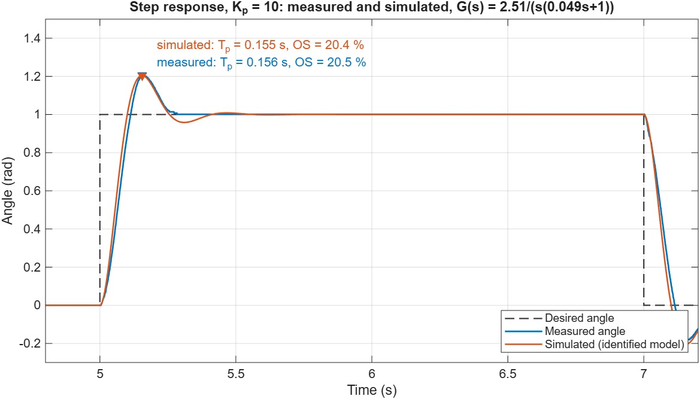
Figure 8 Square wave response, actual system and simulated model

Frequency response modeling
In this section, we'll utilize a frequency response from a chirp signal to determine the second order system's transfer function. From this, we can then derive the first order transfer function of the DC motor, employing the same approach as outlined in the preceding section.
- Using the same “HexaMotor_Position_Control_V03.slx” Simulink model. Move the switch to a chirp input.
- Run the experiment.

For the Report:
- Utilize the closed-loop chirp response to estimate the second order system's transfer function using the 'tfest' function in MATLAB. Then, estimate the DC motor's transfer function based on the approach we previously outlined and practiced in the pre-lab section.
Hint: use the following Matlab commands:
grid, axis labels, title to the plot).
% Estimate transfer function
s=tf('s');
data = iddata(ScopeData.signals.values(:,2),ScopeData.signals.values(:,1),0.001);
T=tfest(data,2,0)
- Create a plot in Matlab which contains the response from the recordings and as a simulation using the lsim function in Matlab for the identified transfer function.
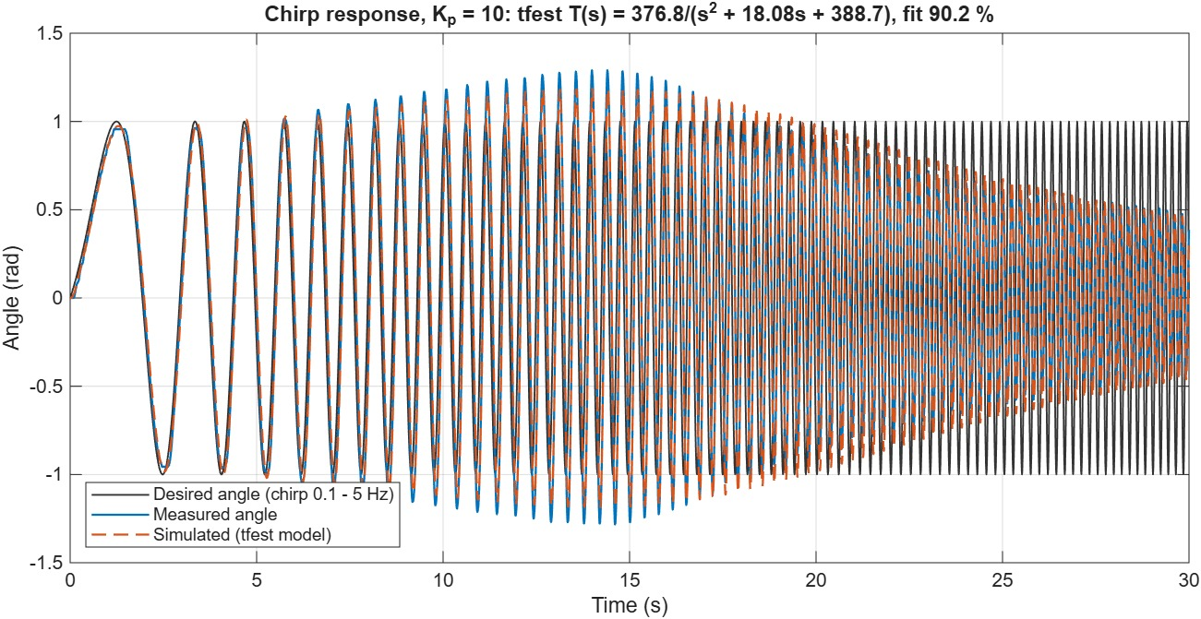
Figure 9 Frequency response, actual system and simulated model

PD controller
In this section, drawing on the approach used in the pre-lab section and based on the transfer function previously determined using the frequency response, we will harness the characteristics of a canonical second-order transfer function. Our objective is to design a PD controller tailored to meet specific criteria: an overshoot (OS) of 25% and a peak time (Tp) of 0.13 seconds.
- Using the same “HexaMotor_Position_Control_V03.slx” Simulink model. Move the switch to Pulse Generator input.
- using the approach from the pre lab section calculate the Kp​ and Kd​. Of the PD controller and update its values in simulink, (Use the motor transfer function found using the frequency response system identifcation method). Keep Ki=0.
- Run the experiment.

For the Report:
- Create a plot in Matlab which contains the response from the recordings and as a simulation using the lsim function in Matlab for the identified transfer function and the calculated PD controller.
Mark peak time and over-shoot values for both signals.
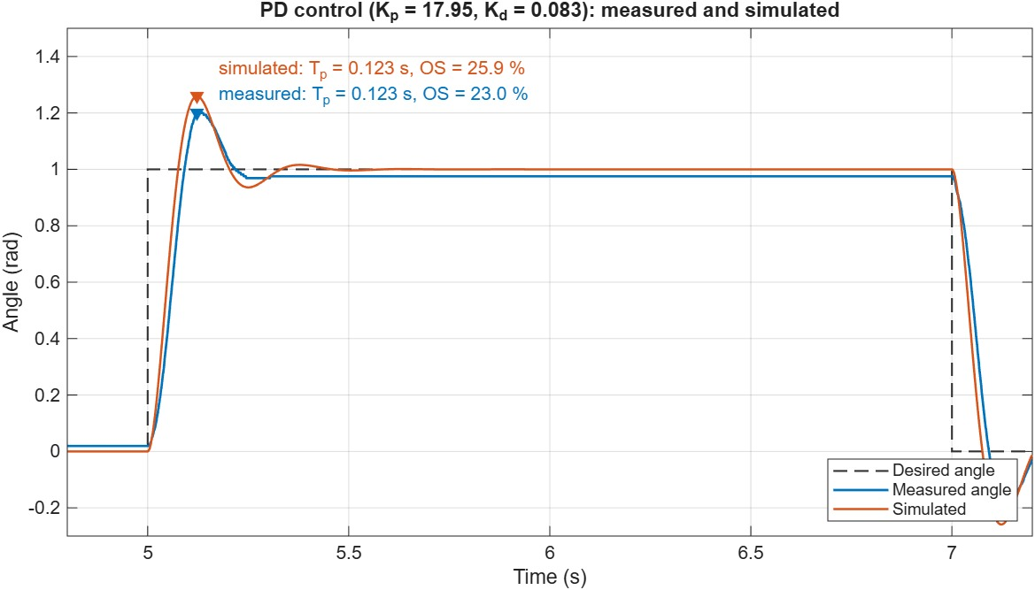
Figure 10 Square wave response with a PD controller, actual system and simulated model

Lead-Lag Compensator
In this section, we'll introduce a lead-lag compensator to enhance the motor's response. Employing the approach adopted in the pre-lab section, our aim is to refine the system's phase margin to $60°$.
- Open the “HexaMotor_LeadLag_Control_V03.slx” Simulink model. Make sure the switch is set to Pulse Generator input.
- Using the approach from the pre lab section calculate the necessary Lead compensator and update its values in the simulink Lead-Lag block. The block implements (T1·s+1)/(T2·s+1), so for the lead compensator (1+aτs)/(1+τs) set T1 = a·τ and T2 = τ. Keep Ki=0 in the PID block.
- Update the PD controller values to the ones found in the lab
- Run the experiment.

For the Report:
- Present your calculations and illustrate the variations in the system's Bode plot.
- Create a plot in Matlab which contains the response from the recordings and as a simulation using the lsim function in Matlab. Mark peak time and over-shoot values for both signals.
Bonus: Redo the experiments and record the response of the system with the Pulse generator signal for the following controllers:
- Proportional gain only kp=10,
- PD controller found in the lab.
- LeadLag Controller with the PD controller.
Plot on the same plot the response from the 3 recordings. Make your conclusion regarding the performance of the designed controller.
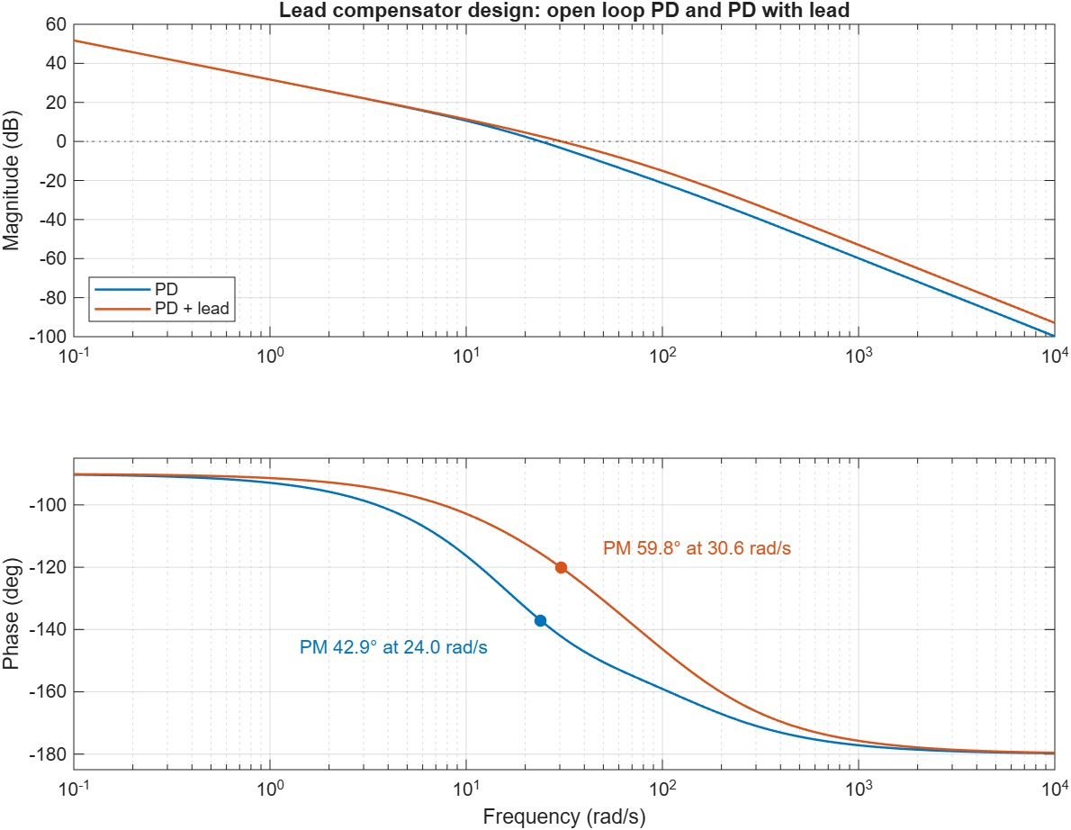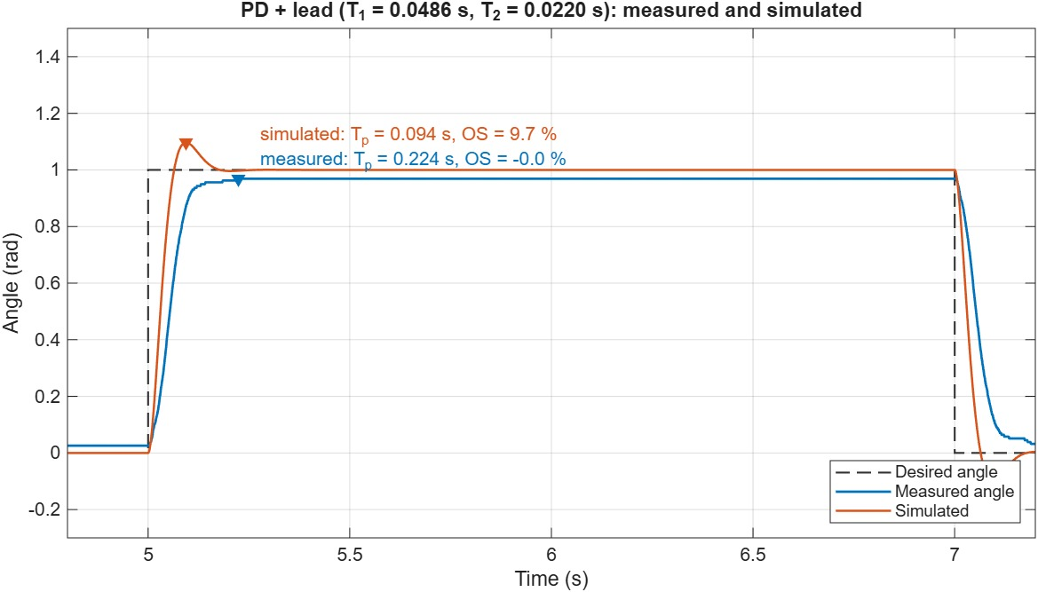
Figure 11 LeadLag design and system response
Note: With the PD and PD + lead controllers the measured response stops slightly short of the set point (about 3-6 %). Close to the target the controller output plus the friction pre-amp is lower than the voltage needed to move the motor (Coulomb friction), so the motor sticks. The simulation includes neither the friction nor the ±12 V limit of the motor driver: with the lead compensator the command saturates during the step, which is why the measured response has less overshoot than the simulated one.

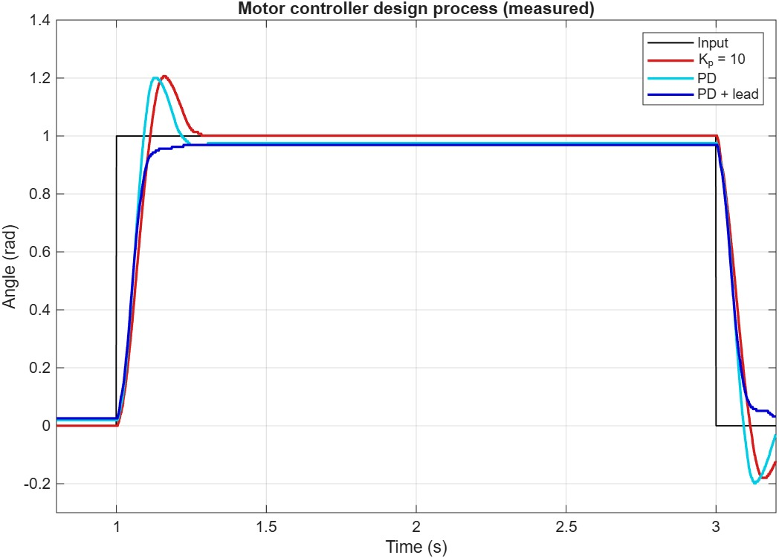
Figure 12 Controller design process, Square wave response of various controllers

Appendix
Github Page: https://github.com/TALs-Education/HexaMotor

DC Motor
This gearmotor consists of a low-power, 12 V brushed DC motor combined with a 20.4:1 metal spur gearbox, and it has an integrated 48 CPR quadrature encoder on the motor shaft, which provides 979.62 counts per revolution of the gearbox’s output shaft.
Product page: https://www.pololu.com/product/4883
Data Sheet: https://www.pololu.com/file/0J1829/pololu-25d-metal-gearmotors.pdf

Arduino board / Motor Driver
The Arduino Uno R4 Minima board (Renesas RA4M1, 48 MHz Arm Cortex-M4) reads the encoder and drives the motor through the Pololu Dual TB9051FTG Motor Driver Shield for Arduino. The motor is connected to channel M2 (PWM on pin 10, direction on pin 8), and the motor current is measured on A1 through the current sense output of the shield (500 mV/A). The encoder channels are connected to pins 2 and 3.
Uno R4 Minima: https://docs.arduino.cc/hardware/uno-r4-minima
Dual TB9051FTG Motor Driver Shield for Arduino: https://www.pololu.com/product/2520
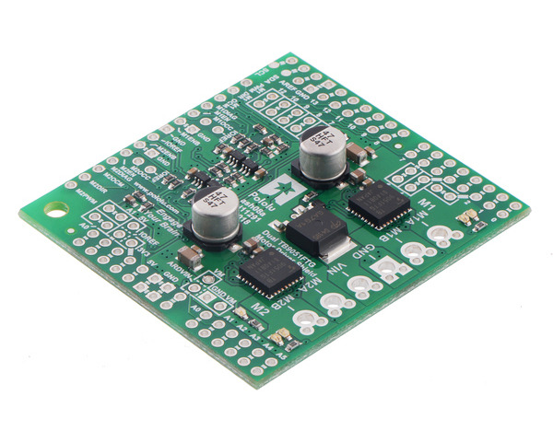
Dual TB9051FTG Motor Driver Shield for Arduino (image: Pololu)

Simulink Support package
With MATLAB and Simulink Support Packages for Arduino® hardware, you can use MATLAB and Simulink to interactively communicate with your Arduino. Simulink also enables you to perform model deployment for standalone operations on Arduino boards.
MathWorks: https://www.mathworks.com/hardware-support/arduino.html

R4 Minima patch
The Arduino Uno R4 Minima needs a patch of the Arduino support packages (rotary encoder, PWM and analog reference support for the Renesas RA4M1). Run applyPatch.m from the R4MinimaPatch folder once, with MATLAB started as administrator, and restart MATLAB. The patch also adds the HexaMotor Encoder block to the MATLAB path. See R4MinimaPatch/README.md for the details.

HexaMotor Encoder block
The HexaMotor Encoder block reads the quadrature encoder in interrupts: 48 counts per motor revolution, 979.62 counts per revolution of the output shaft (0.0064 rad per count). The angle used in this experiment is calculated from the encoder count. The block also measures the angular velocity from the time between encoder ticks (tick-timing velocity, see the Velocity Control manual).

3D Model – Fusion360
The setup is design in Fusion360 as an open source project, for educational purposes. Available at:
Fusion360: https://a360.co/3WoIGKZ

